|  |  |  |  |  | logo1.png |
| --- | --- | --- | --- | --- | --- |

| Course Name | | Zoho Books | |
| --- | --- | --- | --- |
| College Name | | Mangayarkarasi College of Arts and Science for Women Paravai, Madurai - 625002 | |
| College Code | | MKU251 | |
| Skill Offering Id | |  | |
| Project Title | | Preparation and Maintenance of Zoho books for Keerthi Sweets | |
| Project Submitted To | | Madurai Kamaraj University ( Naan Mudhalvan Scheme(TNSDC)) | |
| Year | | 2023 | |
| Department | | B.com | |
| Semester | | 5 | |
| Group Number | | 9 | |
| Total Members of the Group | | 4 | |
| Group Members Details | | | |
| Name of the Member | University Register. No | | Student NM ID |
| M. Ramyapandi | C1C15397 | | 347EFD33BC009F588124EBC784C5B4E4  NM2023TWID36320 |
| P. Alagumeena | C1C15353 | | C85800CA481AA379A7D4228857306C13 |
| K. Someena | C1C154409 | | C1F94D756873F4594B14BD86CFA02984 |
|  |  | |  |
|  |  | |  |
| Under the Guidance | | R. Anu | |
| SPOC | | Ms.P.UMADEVI | |

**Preparation And Maintenance Of ZOCO Books For Keerthisweets**

1. **Introduction.**

*1.1 Overview*

Keerthi Sweets a Manufacturer and Trader of Sweets, relies on Zoho Books to manage their inventory,

handle purchase orders, and generate invoices for their customers. They can track stock levels,

manage supplier payments, and generate financial reports. Zoho Books helps them streamline their

wholesale operations and optimize inventory management.

*1.2 Purpose*

Keerthi Sweets is a renowned manufacturer and trader of delectable sweets, catering to both wholesale

And retail customers. With a rich heritage spanning several decades, Keerthi Sweets has earned a

Reputation for its commitment to quality, authenticity, and customer satisfaction. Specializing in a wide

Variety of traditional and innovative sweets, they combine traditional recipes with modern techniques

To create flavors that tantalize taste buds

1. **Problem Definition and Design Thinking**
   1. Empathy Map 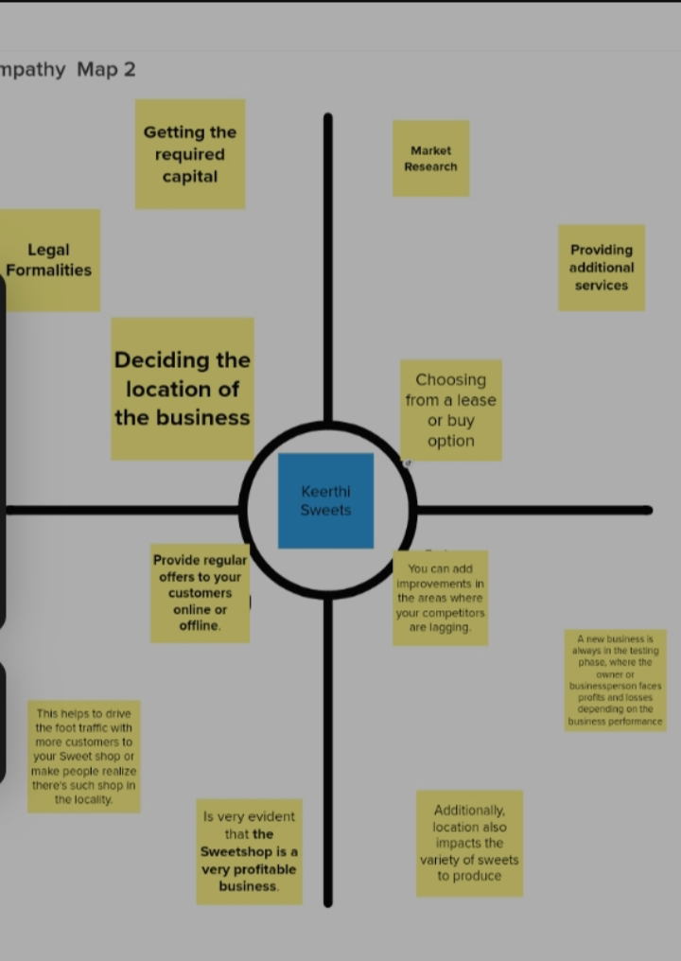

2.2 Ideation and Brainstroming Map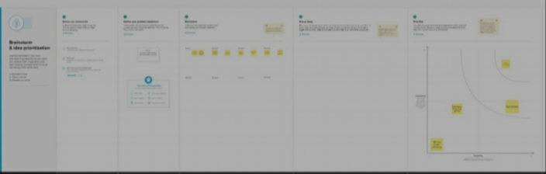

1. Result:

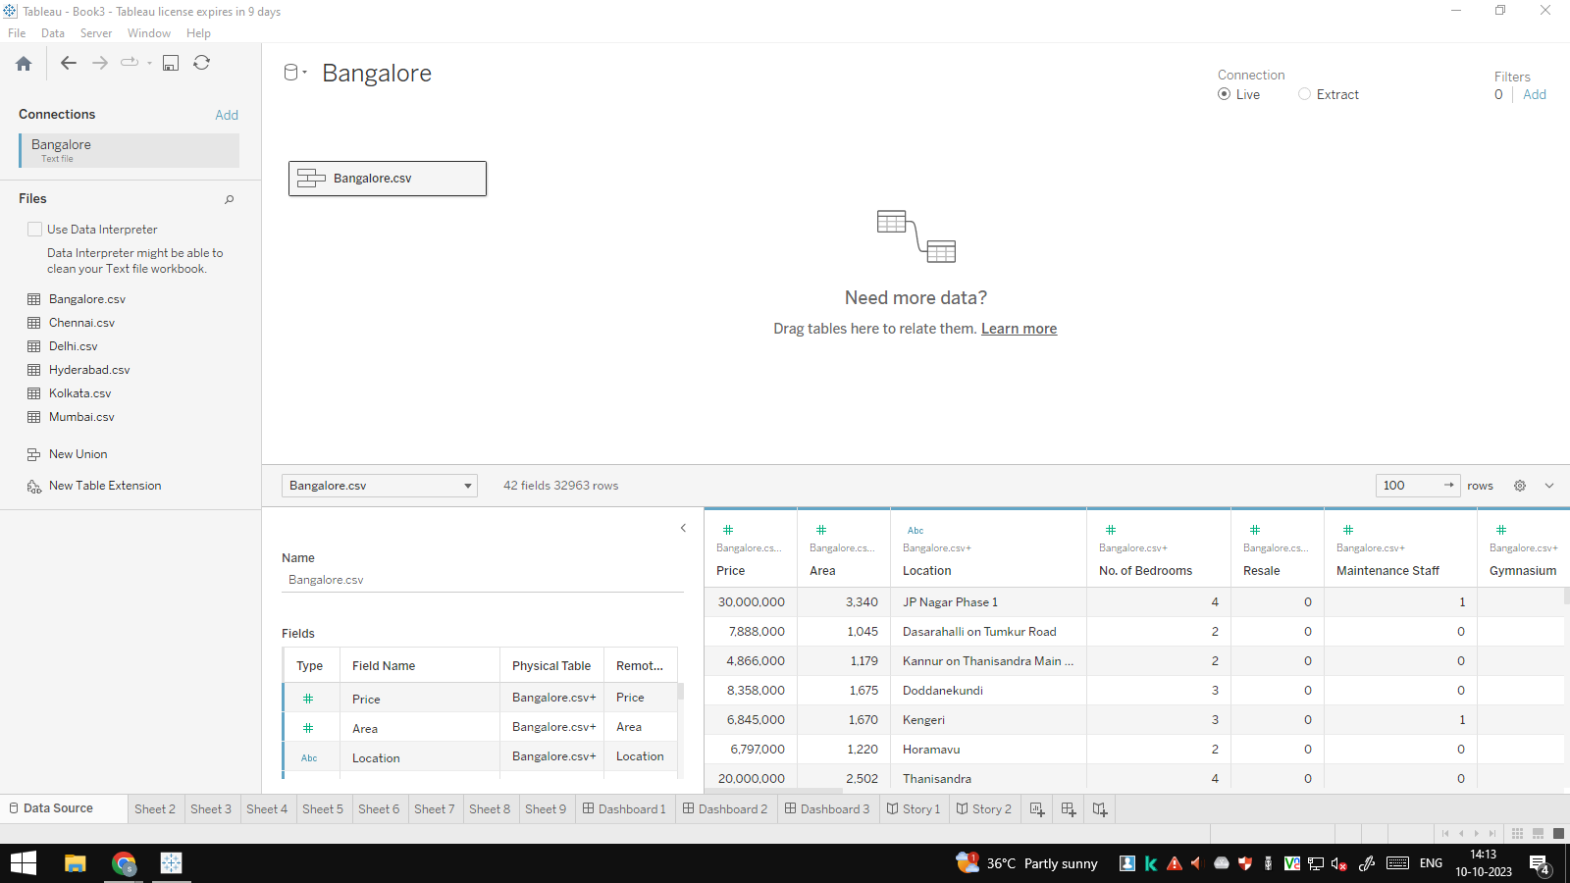

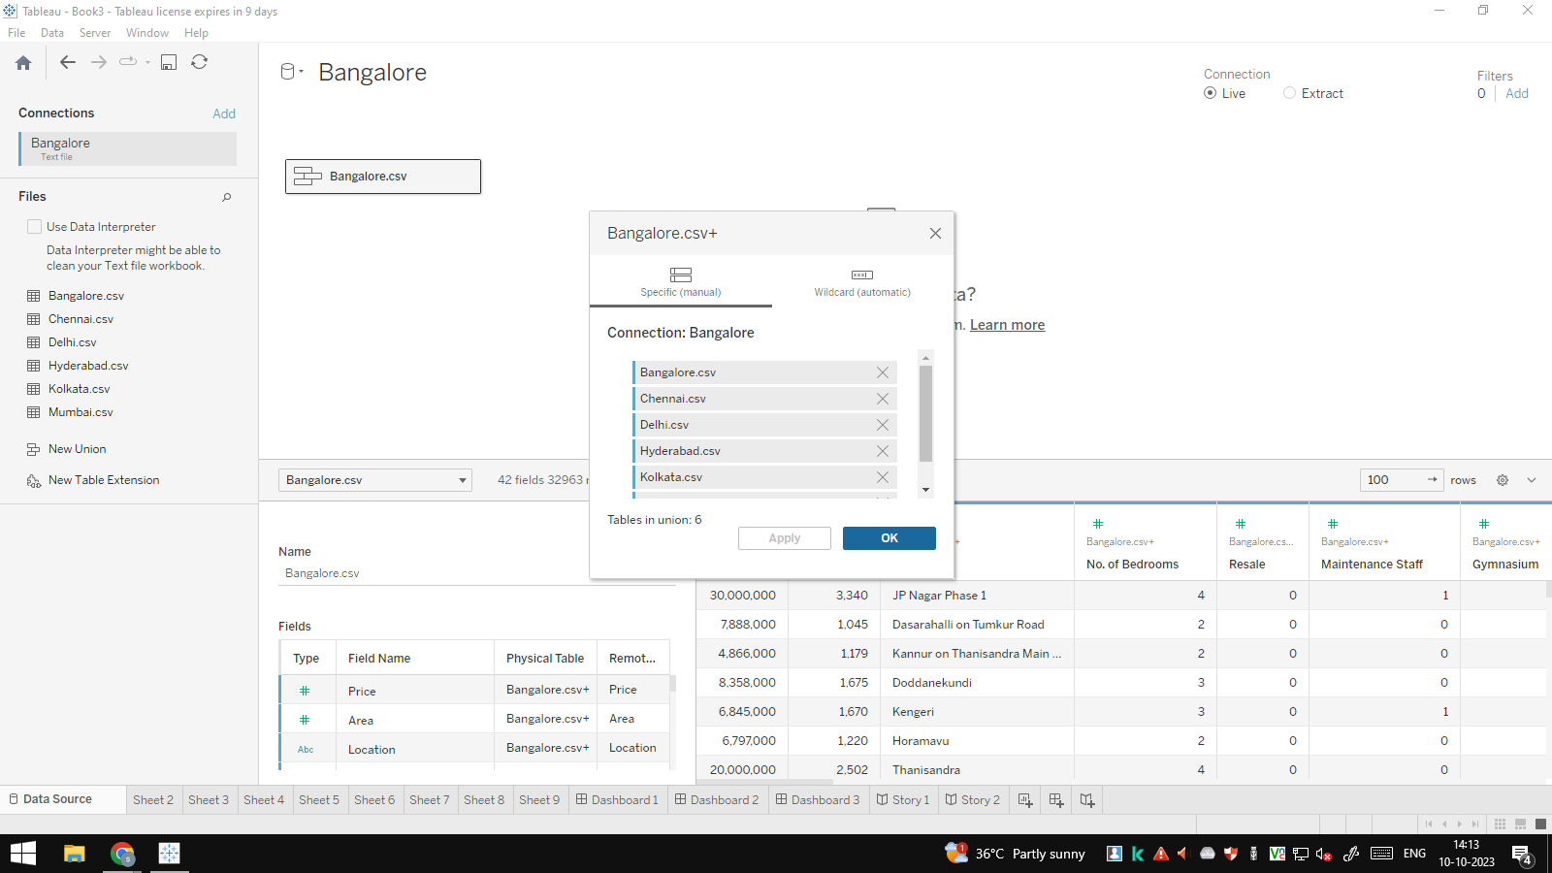

To sign up for Zoho Books:

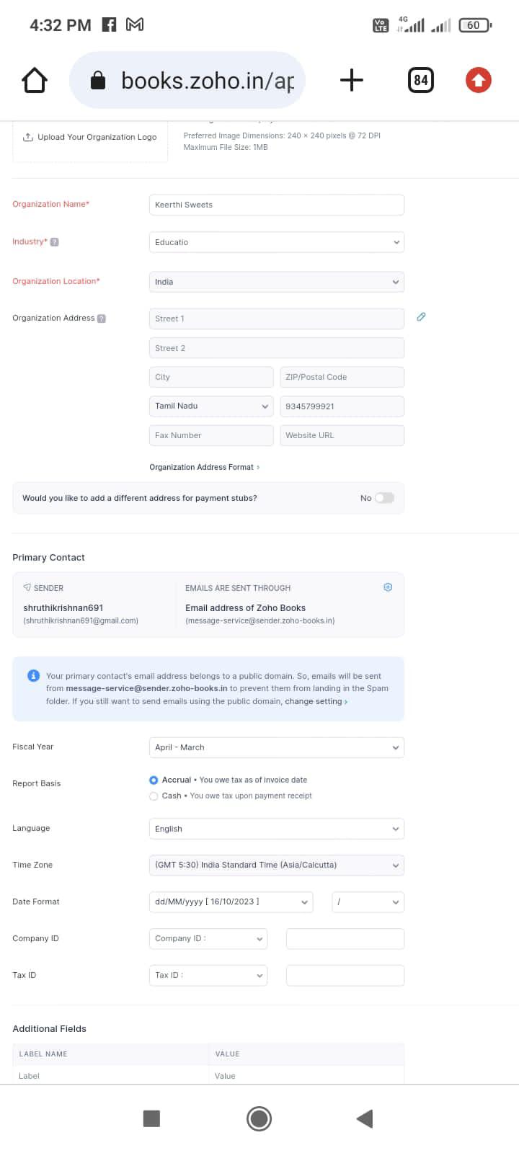

Activity 2: Introduction

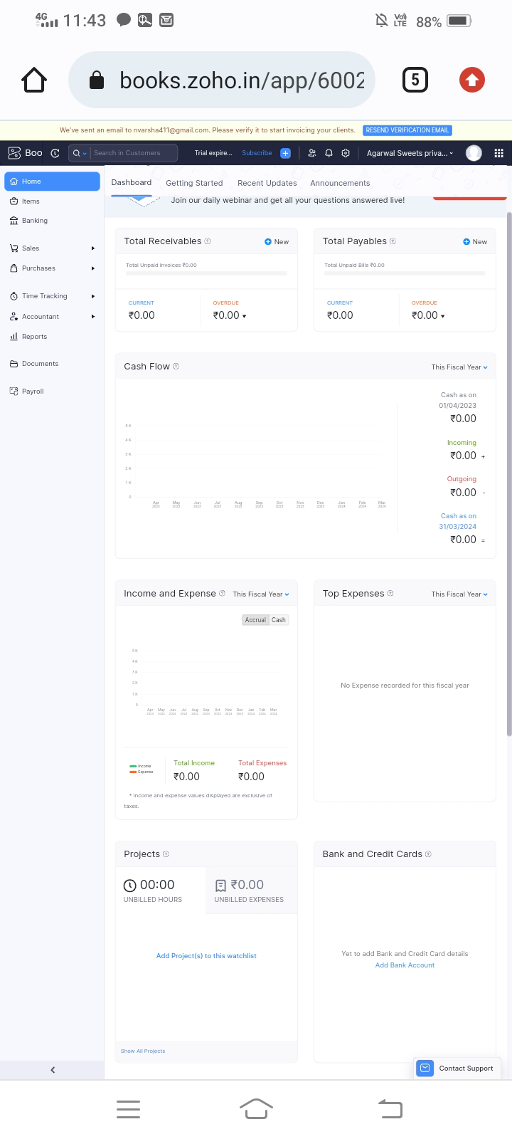

Milestone 2: Products/ItemsActivity 1: Creation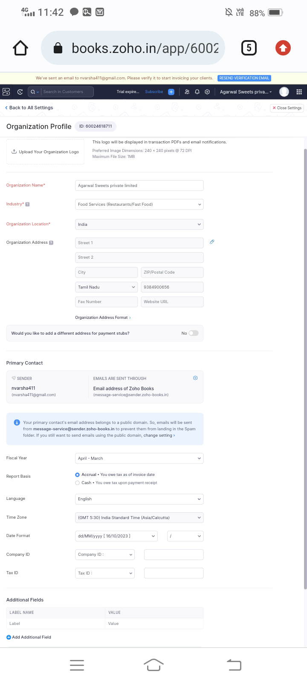

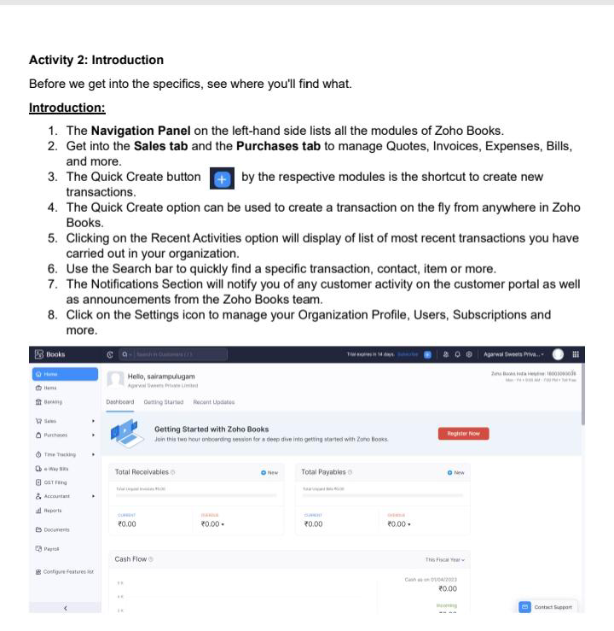

Activity 2: Rewiew of Items after Addition

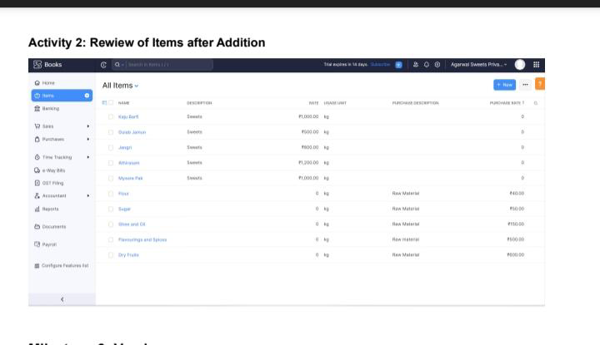

Milestone 3: Vendors

Activity 1: Vendors Creation

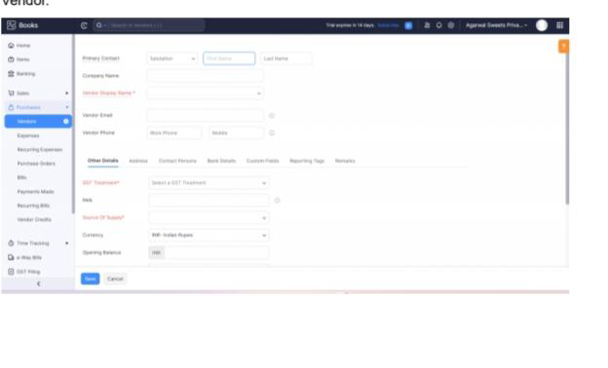

Activity 2: Review of Vendors List

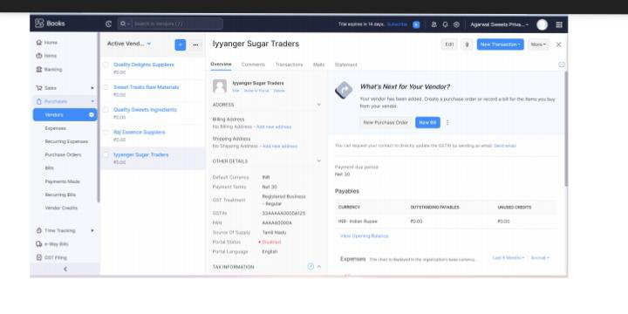

Milestone 4: Purchases

Activity 1: Purchase Order Creation

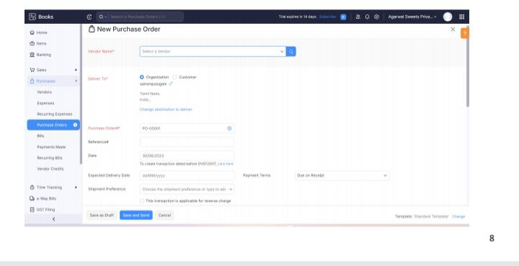

Activity 2: Purchase Order to Purchase Bills Convertion

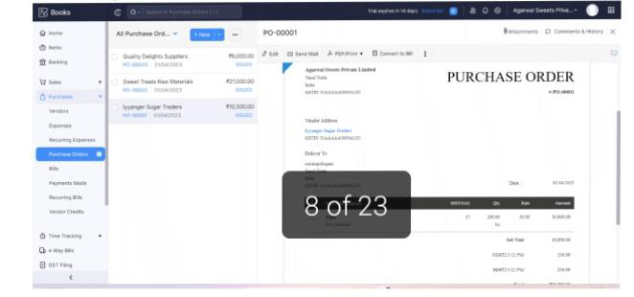

Activity 3: Direct Vendor Purchases Bills Creation:

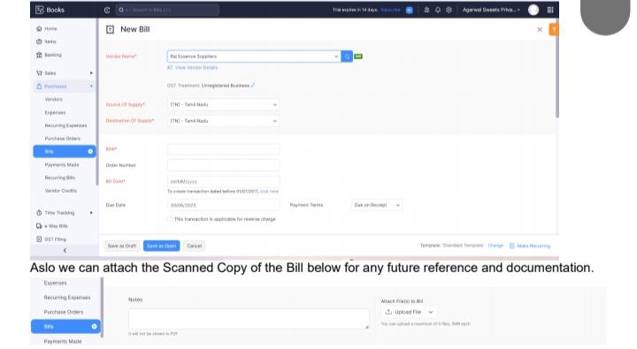

Activity 4: Payment Marking to Purchase Bill

Activity 5: Reconciliation of Open Bills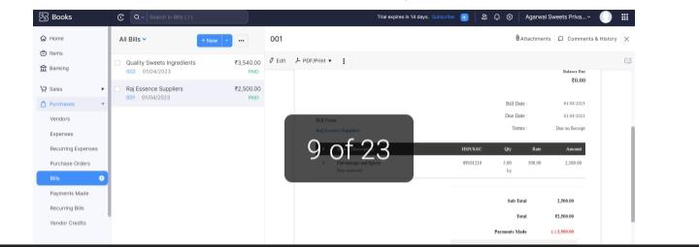

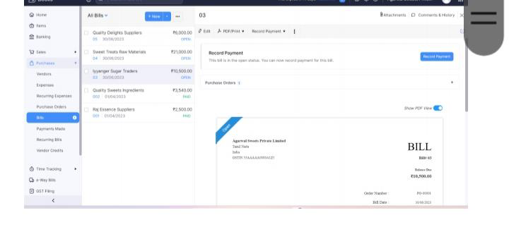

Milestone 5: Customers

Activity 1: Customers Creatio

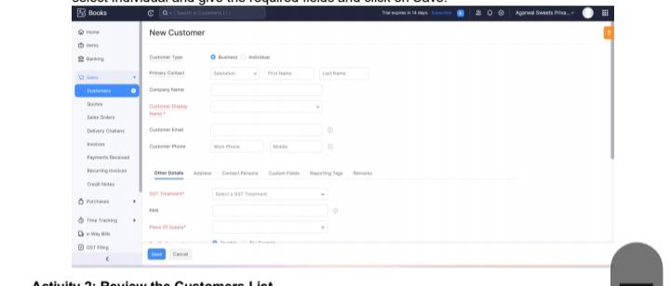

Activity 2: Review the Customers List

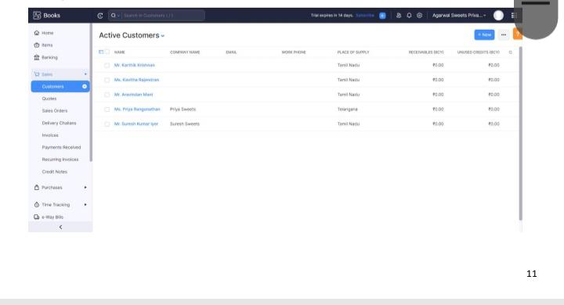

Milestone 5: Customers

Activity 1: Customers Creation:

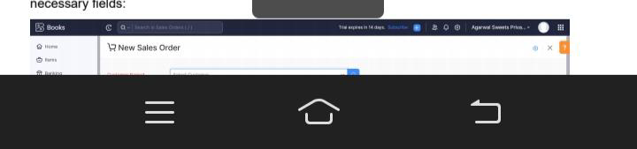

Activity 2: Review the Customers List

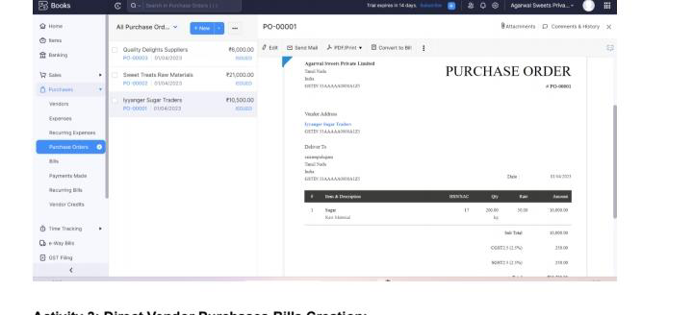

Milestone 6: Sales

Activity 1: Sales Order Creation

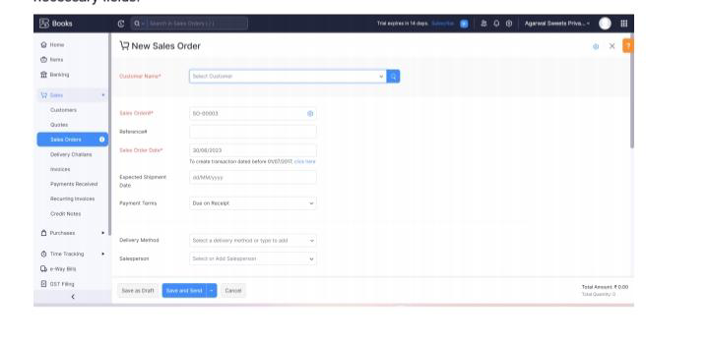

Activity 2: Sales Order to Sale Invoice Convertion

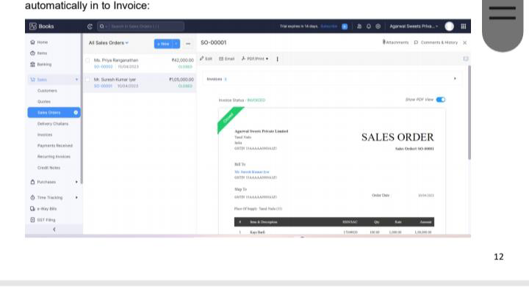

Activity 3: Direct Sale Invoices

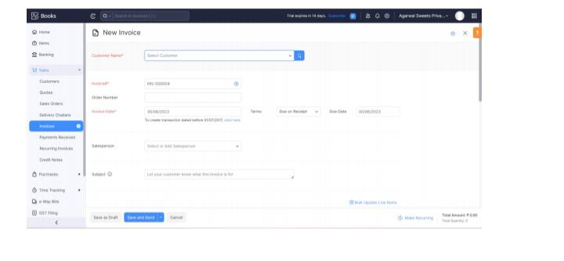

Milestone 11: Bank Entries

.Date Paritculars Debit Credit Balance

01-04-2023 Capital Deposit 100000 100000

01-04-2023 Cash Withdrawl for petty cash 10000 90000

10-04-2023 Paid to Iyyanger Sugar Traders 10500 79500

10-04-2023 Paid to Sweet Treats Raw Materials 21000 58500

10-04-2023 Paid to Quality Delights Suppliers 6000 52500

25-04-2023 Amount received from customer Mr. Suresh Kumar 105000 157500

30-04-2023 Rent Payment 23600 133900

30-04-2023 Petty Cash Deposit 50000 183900

1. **Conclusion:**

Keerthi Sweets is a Private Limited company also registered under GST in Tamil Nadu. Keerthi Sweets is a Manufacturer and trader of various sweets in wholesale and retail, it has a wide range of customers (B2B & B2C) all over the state and it procures raw material from various suppliers in the state. It operates at a Gross Profit margin of 50%.

1. **Future scope:**

Sweet business is very profitable and financial rewarding, mostly yield a good profits in Business you can make private label any of your products , this gives you an advantage by Presenting exclusive products to your customers .